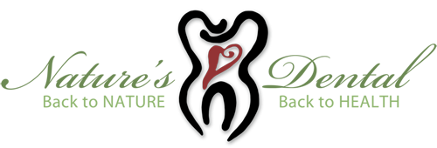
Nature's Dental, 50 Broadway, Greenlawn, NY 11740
Office Policies and Procedures

- Payment is expected in full at the time of service. We accept cash, check, VISA/Master Card/Discover and debit cards. If you do have dental insurance and able to be seeing out of network, please provide us with your dental insurance information and we'll be happy to send a claim on your behalf for maximum possible reimbursement from your insurance company directly to you.
- ____(initial here) We reserve time on the schedule specifically for you. Therefore, missed appointments will be billed according to the procedures scheduled for that day unless cancelled 48 hours in advance. This gives us adequate time to schedule another patient in that time slot.

If you have any questions or concerns, please feel free to call us @631-316-1618 or email @drolga@naturesdental.net

Patient/Parent Signature Date

